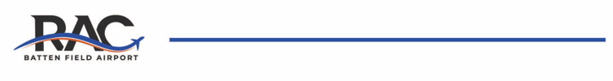
Airport Winter Operations – Snow Removal Equipment Operator
Location: Batten Field Airport – 3239 N. Green Bay Rd., Racine, WI
Job Type:
Seasonal / On-Call / Part-Time
Job Summary:
The Airport Snow Removal Equipment Operator is responsible for maintaining safe and operational airfield surfaces during winter weather conditions. Duties include operating snowplows, runway deicing vehicles, and other specialized equipment to remove snow and ice from runways, taxiways, aprons, and airport roadways. This position requires knowledge of airport operations and adherence to FAA safety regulations.
Key Responsibilities:
- Operate snow removal equipment including plows, sweepers, blowers, and deicing trucks.
- Monitor weather and surface conditions to respond promptly to snow and ice events.
- Apply deicing/anti-icing materials to airside and landside surfaces.
- Coordinate with Airport Operations for runway/taxiway status updates – NOTAM issuance.
- Perform daily vehicle inspections, minor maintenance, and fluid checks.
- Adhere to all safety and airport security procedures.
Qualifications:
- Valid driver’s license.
- Prior experience operating heavy equipment in snow/ice conditions.
- Familiarity with airport layout and airfield operations (preferred).
- Ability to work in extreme weather conditions and during irregular hours (nights, weekends, holidays).
- Capable of working independently or as part of a team under minimal supervision.
Preferred Skills:
- Experience with runway deicing application systems.
- Understanding of FAA and TSA safety/security standards.
- Ability to read and interpret maps, radio communications, and airport signage.
Working Conditions:
- Outdoor work in cold, snowy, or icy conditions.
- Shift work, including overnight and on-call availability.
- Must be able to lift up to 50 lbs and perform physical tasks as needed.
If interested, please contact Mike Wasik referencing the job opportunity to:
Mike Wasik, Assistant Airport Manager
mwasikjr@battenairport.aero

